ABRAR UL HASSAN 25K 6534

Github https://github.com/k256534/PF-labs

QUESTION 1
#include <stdio.h> float triageScore(int severity, int age, int vitals); int main() { int severity, age, vitals; float score;

printf("Enter severity (1-10): "); scanf("%d", &severity);
printf("Enter age risk factor (1-10): "); scanf("%d", &age);
printf("Enter vitals stability (1-10): "); scanf("%d", &vitals);

score = triageScore(severity, age, vitals); printf("Triage Score = %.2f\n", score); if (score > 7.0) { printf("Immediate attention required\n");
}
else if (score >= 4.0 && score <= 7.0) { printf("Moderate priority\n");
}
else { printf("Can wait\n");
}
return 0;
}
float triageScore(int severity, int age, int vitals) { return (severity * 0.5) + (age * 0.3) + (vitals * 0.2);
}
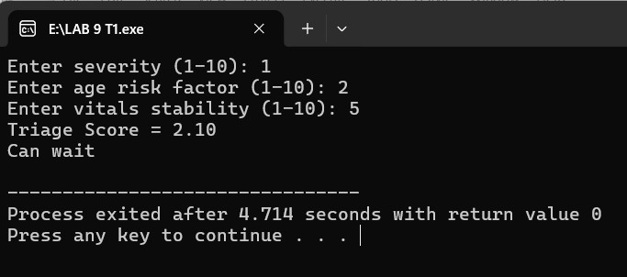

QUESTION 2
#include<stdio.h> float applyDiscount(float price, int tier); void printInvoice(float original, float discounted); int main() { float price, discountedPrice;
int tier;
printf("Enter original price: "); scanf("%f", &price);
printf("Enter membership tier (1=Bronze, 2=Silver, 3=Gold, 4=Platinum): "); scanf("%d", &tier);
discountedPrice = applyDiscount(price, tier);
printInvoice(price, discountedPrice);
return 0; } float applyDiscount(float price, int tier) { float discountRate;
if (tier == 1) discountRate = 0.05; else if (tier == 2) discountRate = 0.10; else if (tier == 3) discountRate = 0.20; else if (tier == 4) discountRate = 0.30; else discountRate = 0.0;
return price - (price * discountRate);
} void printInvoice(float original, float discounted) { float discountAmount = original - discounted; float delivery = 0.0;
if (discounted < 2000) delivery = 150;
float finalTotal = discounted + delivery;
printf("\n----- INVOICE -----\n"); printf("Original Price: Rs. %.2f\n", original); printf("Discount Amount: Rs. %.2f\n", discountAmount); printf("Price After Discount: Rs. %.2f\n", discounted);
if (delivery > 0) printf("Delivery Charges: Rs. %.2f\n", delivery); else
printf("Delivery Charges: Free\n");
printf("Final Total: Rs. %.2f\n", finalTotal);
}
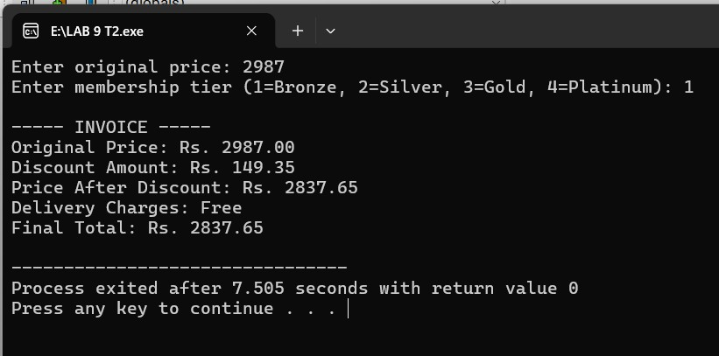
QUESTION 3 #include <stdio.h> int totalRuns(int arr[], int n); int highestScore(int arr[], int n); int aboveAverage(int arr[], int n, float avg); int main() { int scores[10]; int total, highest, count; float average;
printf("Enter runs for 10 matches:\n"); for (int i = 0; i < 10; i++) { scanf("%d", &scores[i]);
}
total = totalRuns(scores, 10); highest = highestScore(scores, 10); average = (float)total / 10; count = aboveAverage(scores, 10, average); printf("\n----- PERFORMANCE REPORT -----\n"); printf("Total Runs: %d\n", total); printf("Average Runs: %.2f\n", average); printf("Highest Score: %d\n", highest); printf("Matches Above Average: %d\n", count);
return 0; } int totalRuns(int arr[], int n) { int sum = 0; for (int i = 0; i < n; i++) { sum += arr[i];
}
return sum;
} int highestScore(int arr[], int n) { int max = arr[0]; for (int i = 1; i < n; i++) { if (arr[i] > max) max = arr[i];
}
return max;
} int aboveAverage(int arr[], int n, float avg) { int count = 0; for (int i = 0; i < n; i++) { if (arr[i] > avg) count++;
}
return count;
}
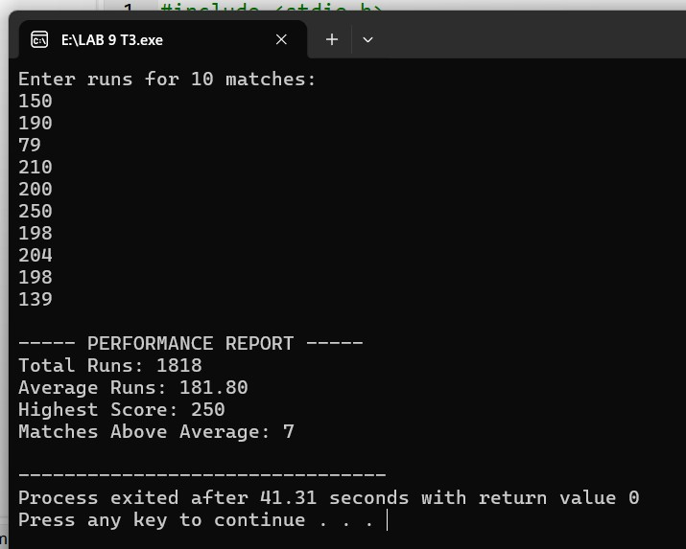

QUESTION 4
#include<stdio.h> int validatePIN(int storedPIN, int enteredPIN); int main() { int storedPIN = 4729; int enteredPIN; int attempts;
for (attempts = 1; attempts <= 3; attempts++) { printf("Enter PIN: "); scanf("%d", &enteredPIN);
if (validatePIN(storedPIN, enteredPIN)) { printf("Access granted. Welcome!\n");
break; } else { if (attempts < 3) printf("Incorrect PIN. Attempts remaining: %d\n", 3 - attempts);
}
}
if (attempts > 3) { printf("Card blocked. Contact your bank.\n");
}
return 0;
} int validatePIN(int storedPIN, int enteredPIN) { if (storedPIN == enteredPIN)
return 1; else return 0;
}
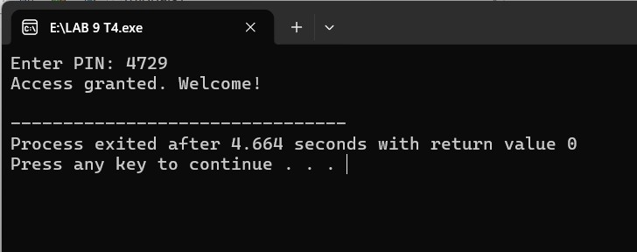
QUESTION 5 #include<stdio.h> float toMegajoules(float kwh); float toBTU(float kwh); float toCalories(float kwh); int main() { float kwh;
printf("Enter energy in kWh: "); scanf("%f", &kwh);
printf("\n----- CONVERSION REPORT -----\n"); printf("Input Energy: %.2f kWh\n", kwh);
printf("Megajoules (MJ): %.2f\n", toMegajoules(kwh)); printf("BTU: %.2f\n", toBTU(kwh)); printf("Calories (kcal): %.2f\n", toCalories(kwh));

}
float toMegajoules(float kwh) { return kwh * 3.6;
}
float toBTU(float kwh) { return kwh * 3412.14;
}
float toCalories(float kwh) { return kwh * 859845;
}
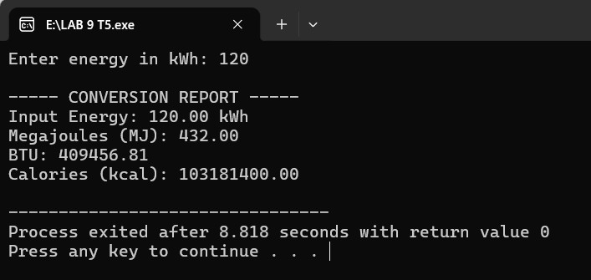
QUESTION 6 #include<stdio.h> float totalRevenue(float bills[], int n); int bestTable(float bills[], int n); int isProfitable(float total); int main() { float bills[5];
float total; int best; int profit;
printf("Enter bill amounts for 5 tables:\n"); for (int i = 0; i < 5; i++) { scanf("%f", &bills[i]);
}
total = totalRevenue(bills, 5); best = bestTable(bills, 5); profit = isProfitable(total);
printf("\n----- CLOSING SUMMARY -----\n"); printf("Total Revenue: Rs. %.2f\n", total); printf("Best Performing Table: Table %d\n", best + 1);
if (profit) printf("Status: Profitable\n"); else printf("Status: Not Profitable\n");
} float totalRevenue(float bills[], int n) { float sum = 0; for (int i = 0; i < n; i++) { sum += bills[i];
}
return sum;
} int bestTable(float bills[], int n) { int maxIdx = 0;
for (int i = 1; i < n; i++) { if (bills[i] > bills[maxIdx]) maxIdx = i;
}
return maxIdx;
} int isProfitable(float total) { if (total > 10000) return 1; else return 0;
}
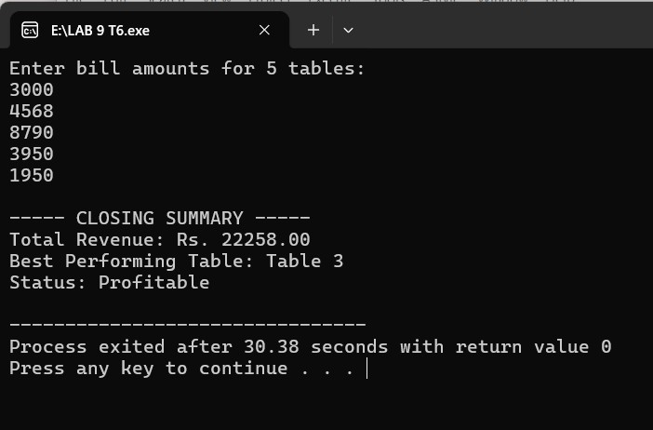
QUESTION 7 #include<stdio.h> int main() { int arr[6]; int *p = arr; int highest; printf("Enter marks of 6 students:\n");
for (int i = 0; i < 6; i++) { scanf("%d", (p + i));
}
printf("\nOriginal Marks:\n"); for (int i = 0; i < 6; i++) { printf("%d ", *(p + i));
}
highest = *p; for (int i = 1; i < 6; i++) { if (*(p + i) > highest) highest = *(p + i);
}
for (int i = 0; i < 6; i++) {
*(p + i) = (int)(((float)*(p + i) / highest) * 100);
}
printf("\n\nScaled Marks:\n");
for (int i = 0; i < 6; i++) { printf("%d ", *(p + i));
}
}
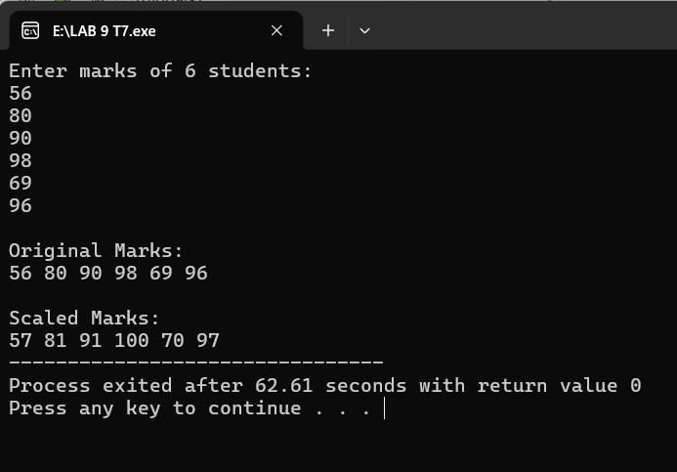
QUESTION 8 #include<stdio.h> int main() { void *sensor; int vibrations = 847; float temperature = 73.6; char status = 'W'; sensor = &vibrations; printf("Vibrations: %d\n", *(int *)sensor); printf("Address: %p\n\n", (void *)sensor);
sensor = &temperature; printf("Temperature: %.2f\n", *(float *)sensor); printf("Address: %p\n\n", (void *)sensor);
sensor = &status; printf("Status: %c\n", *(char *)sensor); printf("Address: %p\n\n", (void *)sensor);
if (*(char *)sensor == 'N') printf("System Normal\n"); else if (*(char *)sensor == 'W') printf("Warning حالت\n"); else if (*(char *)sensor == 'C') printf("Critical Alert!\n"); return 0;
}
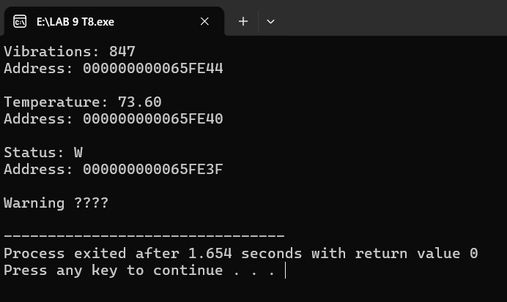
QUESTION 9 #include<stdio.h> int main() { int attendance[4][5] = {
{1, 1, 0, 1, 1},
{0, 1, 0, 0, 1},
{1, 1, 1, 1, 1},
{0, 0, 1, 0, 1}
};
int (*p)[5] = attendance; for (int i = 0; i < 4; i++) { int total = 0;
printf("Student %d: ", i + 1);
for (int j = 0; j < 5; j++) { printf("%d ", (*(p + i))[j]); total += (*(p + i))[j];
}
printf(" | Total Present: %d", total); if (total < 3) printf(" At risk");
printf("\n");
}
}
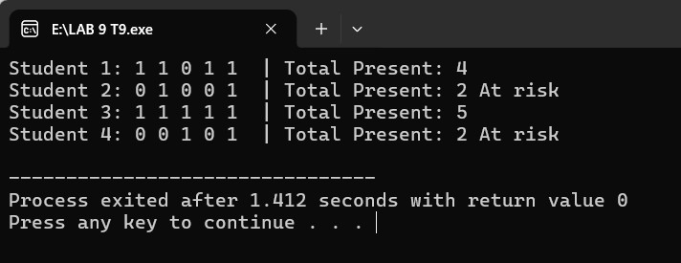
QUESTION 10 #include<stdio.h> int basicAttack(int dmg, int hp) { hp -= dmg; printf("Basic Attack! You dealt %d damage.\n", dmg); return hp;
} int powerStrike(int dmg, int hp) { int totalDmg = dmg * 2.5; hp -= totalDmg; printf("Power Strike! You dealt %d damage.\n", totalDmg); return hp; } int heal(int dmg, int hp) { hp += 20; printf("Heal! You restored 20 HP.\n"); return hp;
} int poisonAttack(int dmg, int hp) { int totalDmg = dmg / 2;
hp -= totalDmg; printf("Poison Attack! You dealt %d damage and inflicted poison.\n", totalDmg); return hp; } int main() { int hp = 100, dmg = 25, choice; int (*action)(int, int); for (int turn = 1; turn <= 3; turn++) { printf("\nTurn %d - Current HP: %d\n", turn, hp); printf("1. Basic Attack\n2. Power Strike\n3. Heal\n4. Poison Attack\n"); printf("Enter choice: "); scanf("%d", &choice); switch(choice) { case 1: action = basicAttack; break; case 2: action = powerStrike; break; case 3: action = heal; break; case 4: action = poisonAttack; break; default: action = basicAttack;
}
hp = action(dmg, hp);
if (hp <= 0) { printf("You have been defeated!\n");
break;
}
}
printf("\nFinal HP: %d\n", hp);
}

